ALL CHILDREN AND YOUTH
HAVE THE RIGHT TO FREE,
APPROPRIATE PUBLIC EDUCATION

Including children and youth with:
- Uncertain housing
- A temporary address
- No permanent physical address

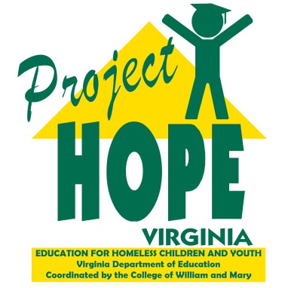
The federal McKinney-Vento Act guarantees school enrollment for anyone who, due to a lack of housing, does not have a fixed, regular, and adequate night time residence. Such children and youth may live:

- In an emergency shelter or transitional housing,
- In a motel, hotel, or campground due to the lack of an adequate alternative,
- In a car, park, public place, bus or train station, or abandoned building,
- Doubled up with relatives or friends due to loss of housing or economic hardship,
- In these conditions and be a migratory child or youth, or
- In these conditions and be a youth not accompanied by a parent or guardian.

Children and youth living in these settings may meet the McKinney Vento definition of homelessness and have additional educational rights.
Where can a child or youth without a fixed, regular, and adequate residence attend school?

- The school the child or youth attended before becoming homeless or was last enrolled (school of origin), or
- The school in the attendance area where the child or youth is currently living
How can delays be avoided when enrolling a student experiencing homelessness in school?
- Enroll the student immediately.
- Contact the previous school and ask that the records be sent electronically or shared over the phone.
- Contact the principal, school counselor, or local homeless education liaison with any concerns.
- Contact the local homeless education liaison to support unaccompanied youth when enrolling in school.

Where can I get help?
Cathey Burks, M.Ed.
McKinney-Vento Liaison
cburks@bedford.k12.va.us
540-588-1876
P.O. Box 8795 ● Williamsburg, VA 23187-8795
757-221-4002 ● Toll Free: 877-455-3412
● Fax: 757-221-5300 ● homlss@wm.edu ● www.wm.edu/hope

